Task: Deploying a Node.js Application Using Nginx as a Reverse Proxy
Objective
The objective of this task is to set up a multi-server environment for building, storing, and deploying a Node.js application with Nginx as the reverse proxy server. The pipeline uses three servers: a Build Server, a Nexus Repository Server, and a Deploy Server.
Source Code
Use the Node.js application repository provided for the assignment from GitHub. The task sheet describes a Node.js app being cloned, built, packaged and deployed through Nexus and Nginx.
Architecture
GitHub → Build Server → Nexus → Deploy Server → Browser
The setup uses three Ubuntu EC2 instances in AWS, each with a separate role in the deployment pipeline. The Build Server handles cloning, dependency installation, build and artifact publishing; the Nexus Server stores the artifact and the Deploy Server runs the application behind Nginx.

Step-1: Build Server Setup (Build-VM)
- Launch Ec2 instance on AWS
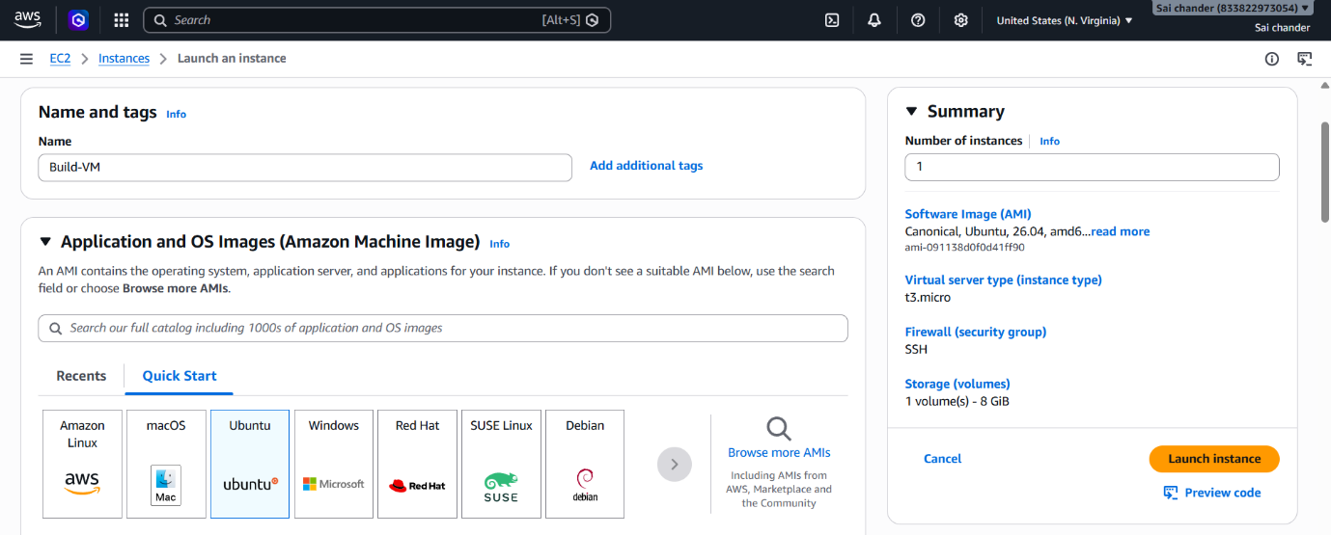
- Name instances as Build-VM

- Select ubuntu AMI
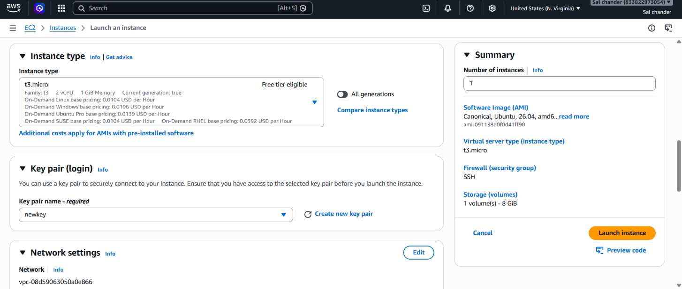
- Select Instance type t3.micro with 2vCPU and 1GB memory, keypair with SSH port 22 and HTTP 80
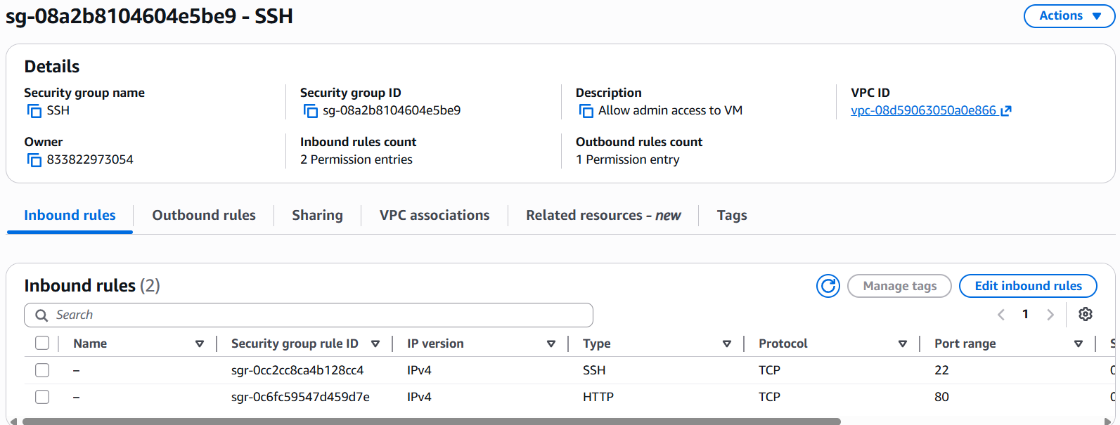

- Launch Instance
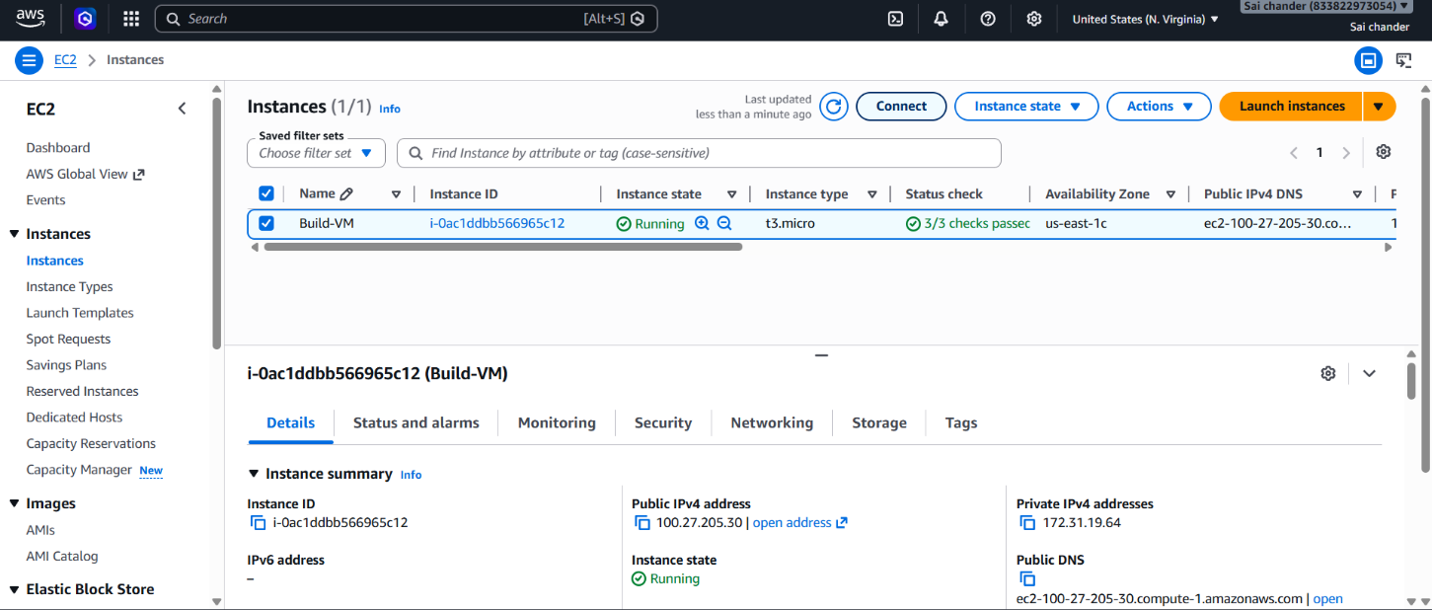
- Instance Running
- Connected to terminal via SSH client
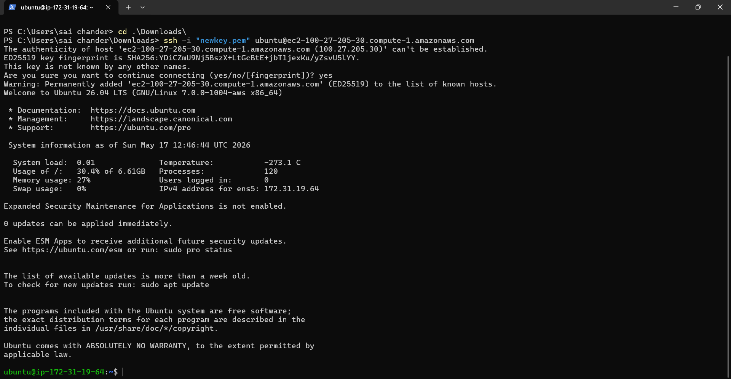
- Check if Git is installed, if not install git
sudo apt install git -y
- clone code from GitHub repository
git clone https://github.com/saichander2311/AngularCalculator.git
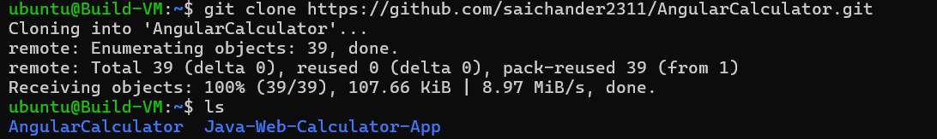
- Install nodejs and npm
sudo apt install nodejs npm -y
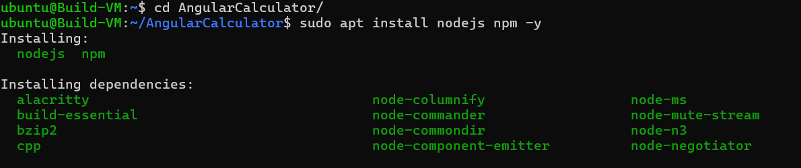

- Check if node and npm are installed
node –version
npm -v
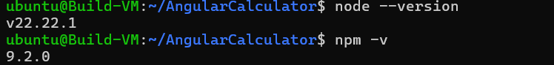
- Install Angularcli
sudo npm install -g @angular/cli
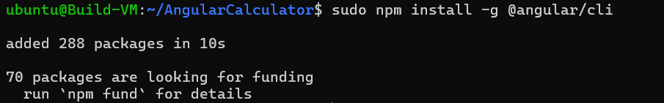
- Download all npm binaries and install them
npm install
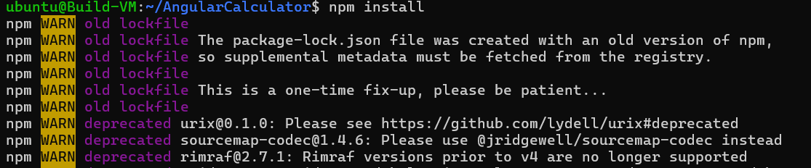

- Build the code, this generates a /dist directory which has build files
ng build
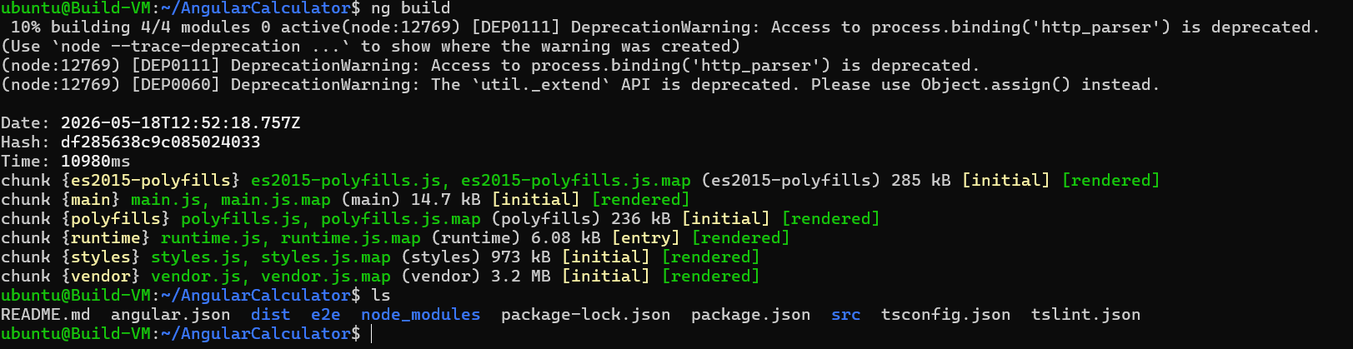
- Now compress the build file in the /dist
zip -r angular-calculator.zip .
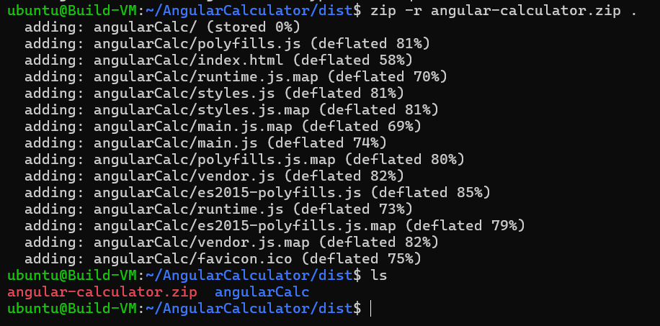
- This will create a .zip file of the build file

Step-2: Nexus Server Setup (Nexus-VM)
- Launch Ec2 instance on AWS
- Name instance as Nexus-VM
- Select ubuntu AMI
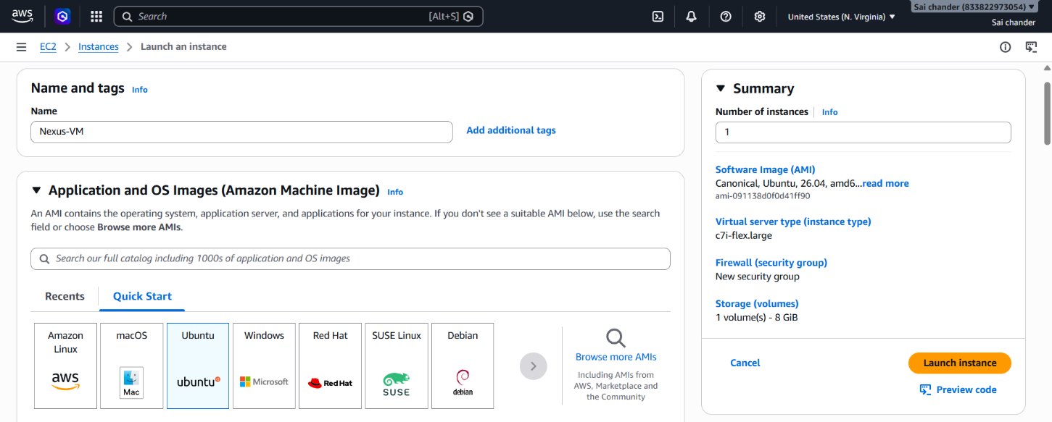
- Select Instance type c7i-flex.large with 2vCPU and 4GB memory, keypair
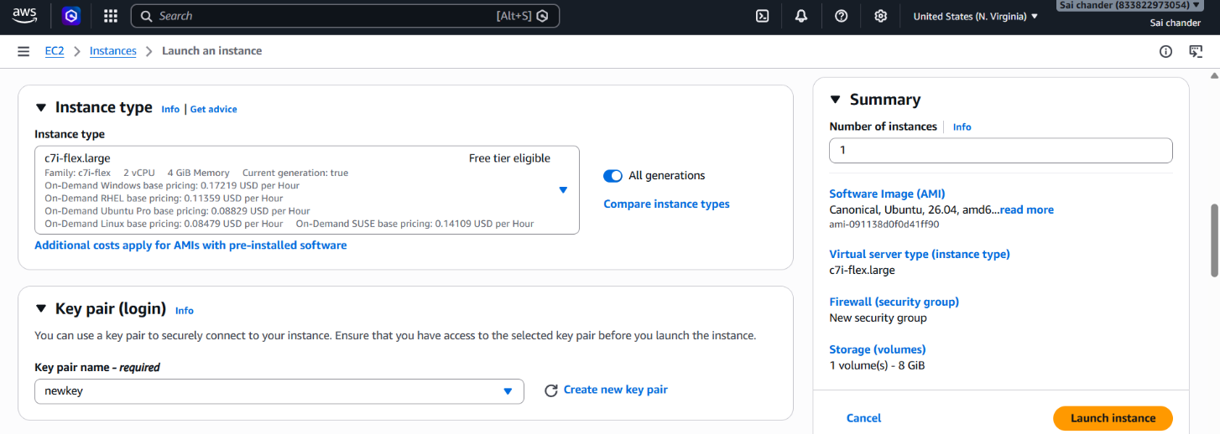
- Security Group rules - SSH port 22 and port 8081(Nexus)
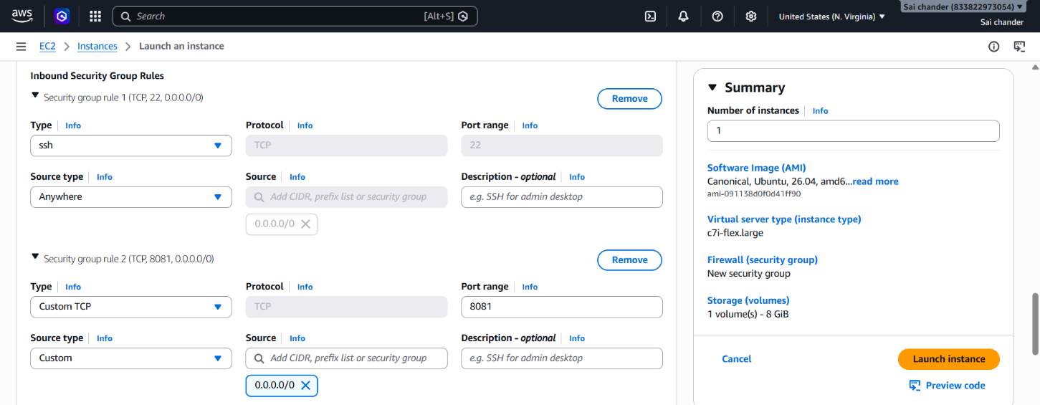
- Launch Instance
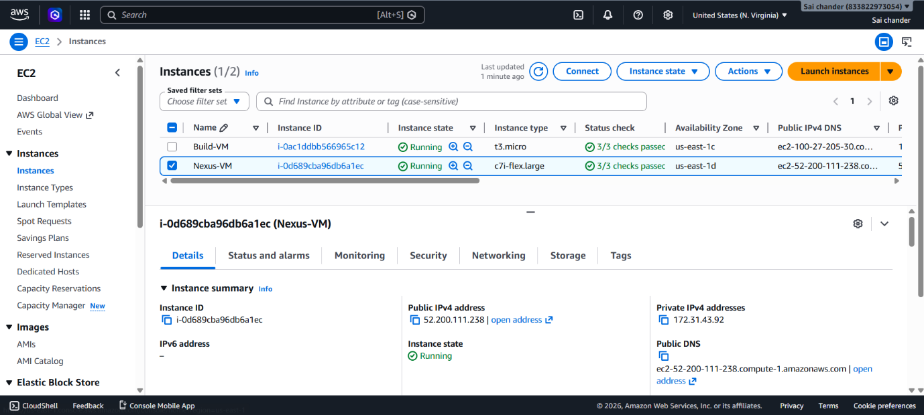

- Instance Running and connected to terminal via SSH client
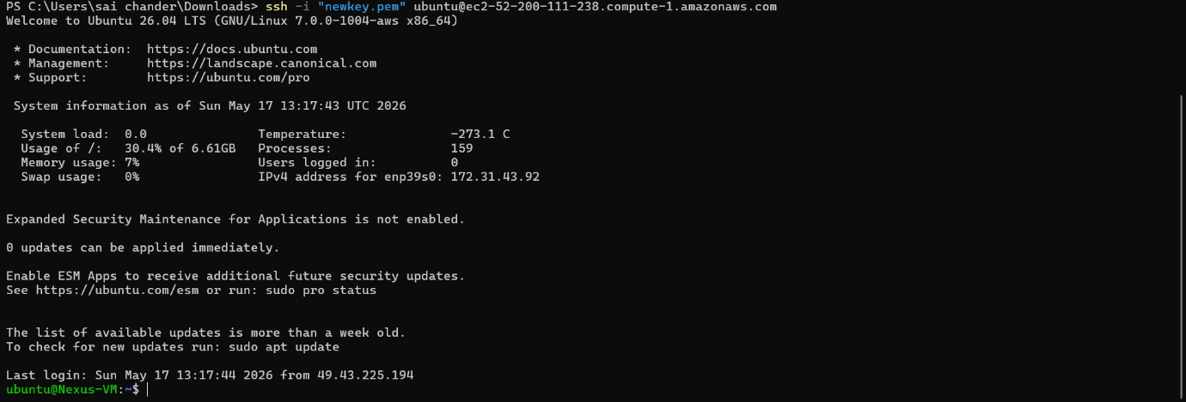
- Install Java 17
sudo apt install openjdk-17-jdk -y
- check java version
java -version
- Download and Extract Nexus
wget https://download.sonatype.com/nexus/3/nexus-3.85.0-03-linux-x86_64.tar.gz
tar -xvzf nexus-3.85.0-03-linux-x86_64.tar.gz
- Start Nexus
cd nexus-3.85.0-03/bin
./nexus start
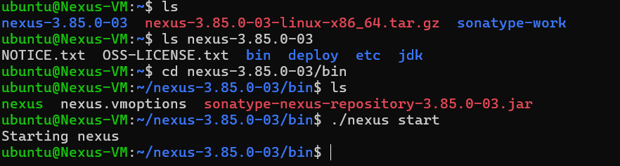
- Nexus started, verify in browser with http://<nexus-ip>:8081
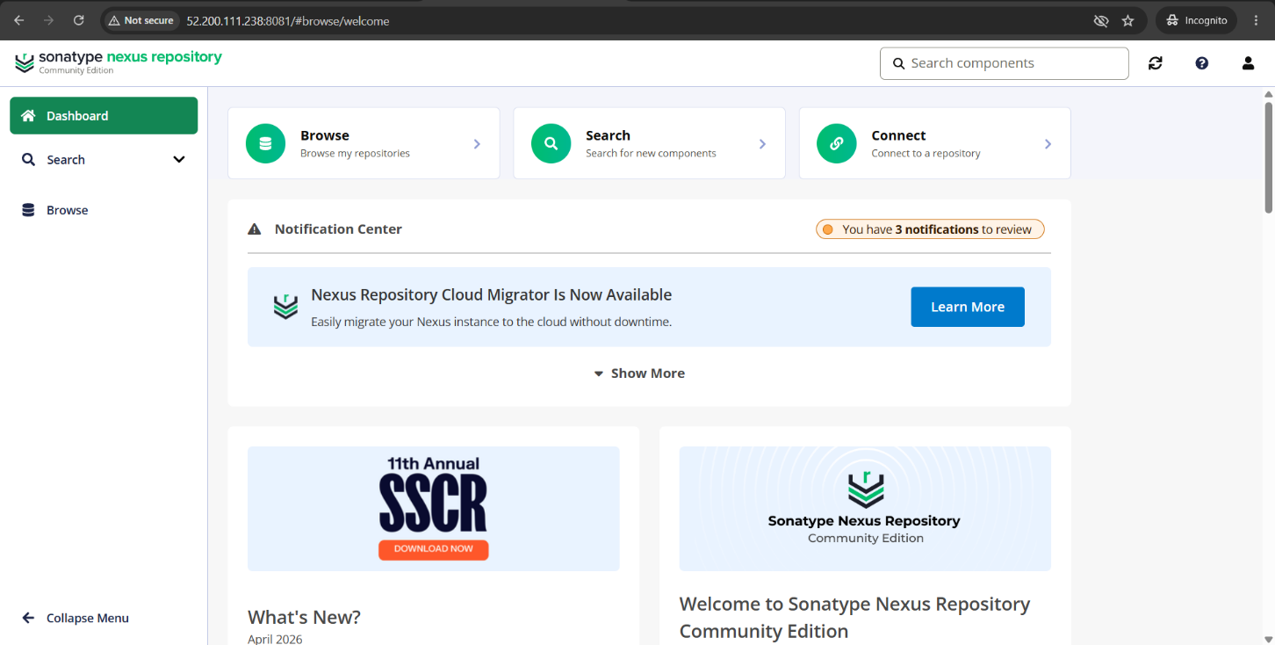
- Nexus is Running in Browser
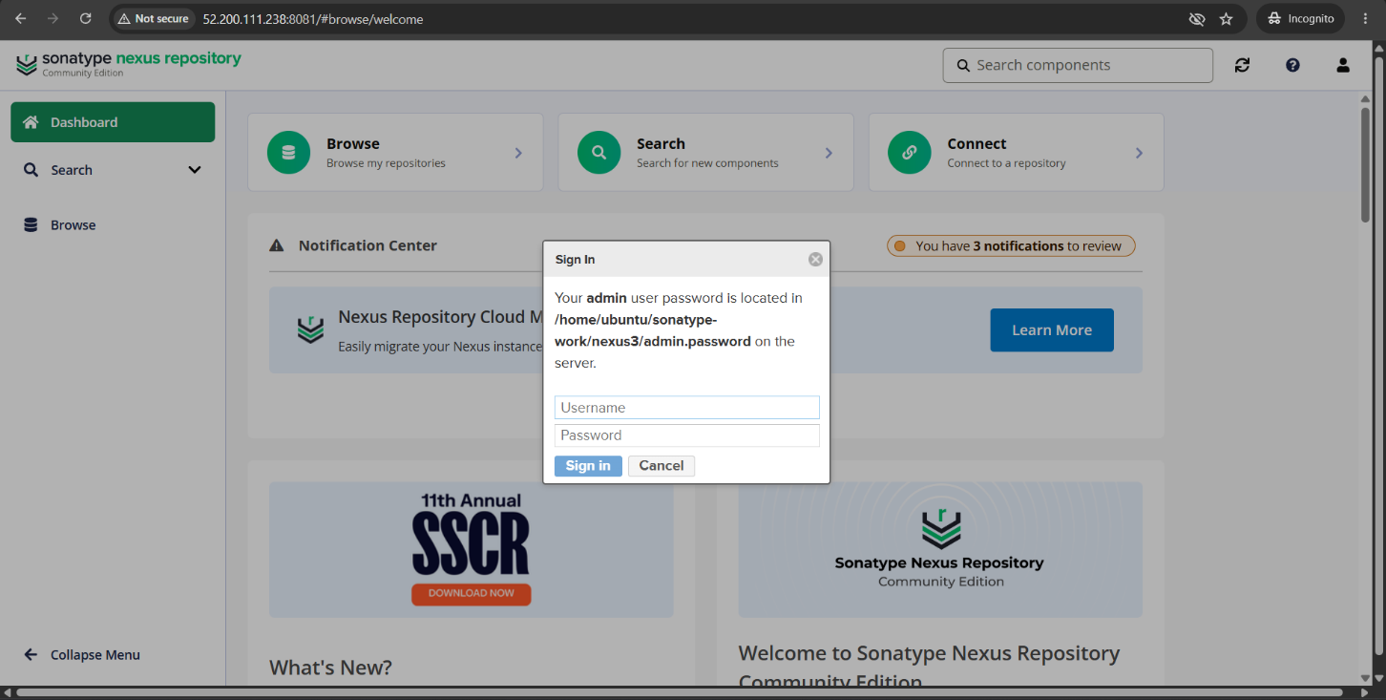
- Nexus Login page
- Retrieve Nexus password at /home/ubuntu/sonatype-work/nexus3/admin.password
- Login Nexus with Username and Password, then change password.
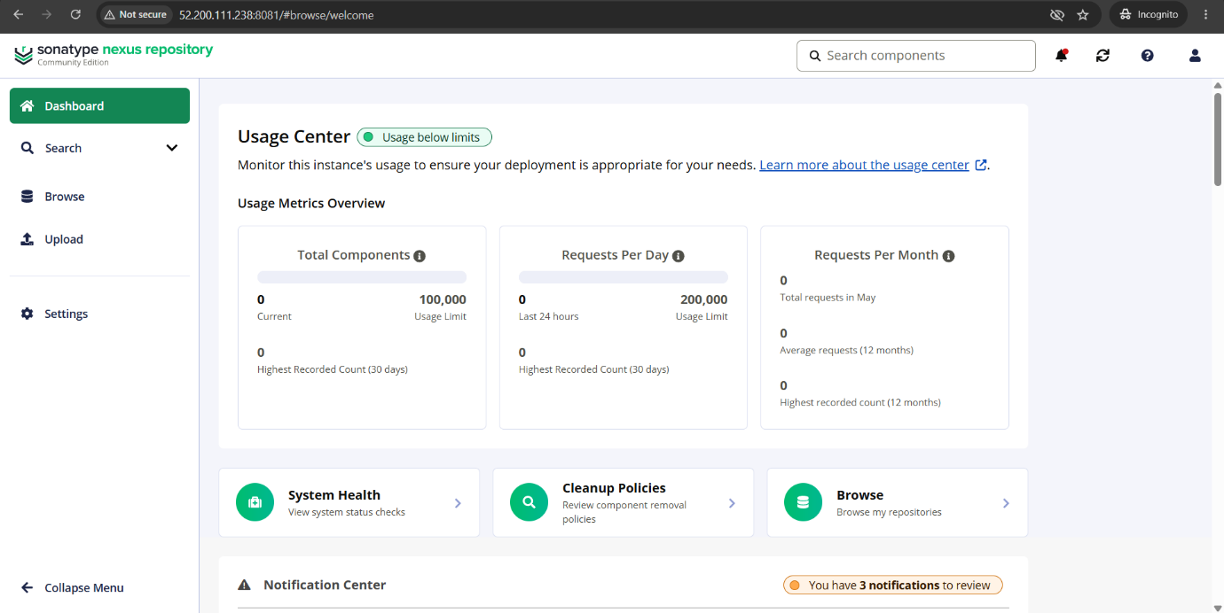
- Nexus dashboard after Login

- Create Repository in Nexus and name it angular-releases
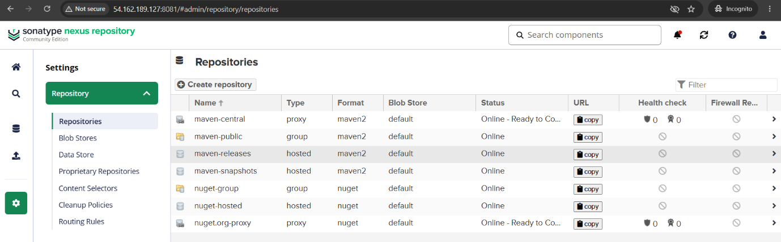
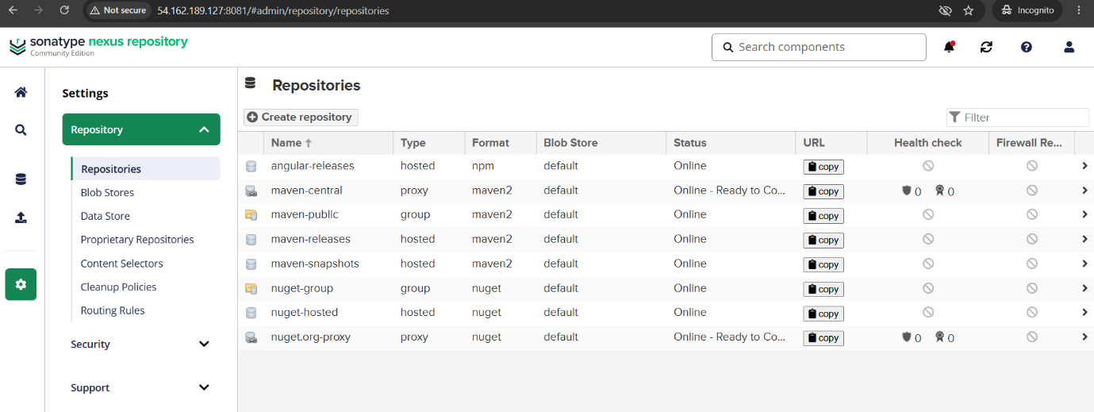
- Copy angular-releases path
- Activate the npm Realm in Nexus
- In Neuxs navigate to Settings (Gear icon) ➡️ Security ➡️ Realms
- In the Available list, look for npm Bearer Token Realm.
- Select it and click the arrow button to move it into the Active list.
- Click Save at the bottom.
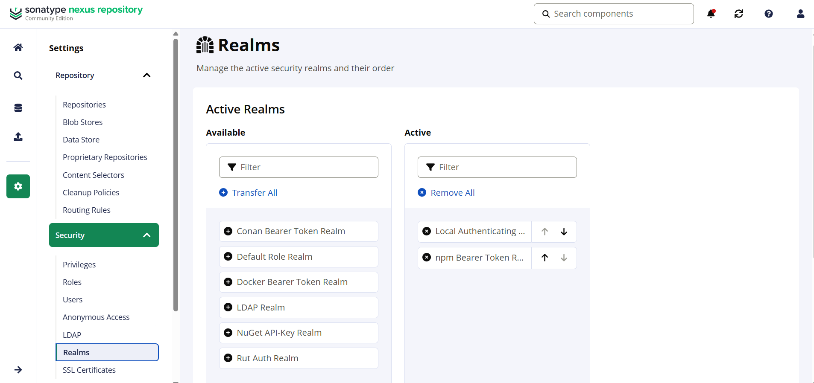
- In Build-VM update package.json file in repository
- Add the "publishConfig" object. And add copied path in registry
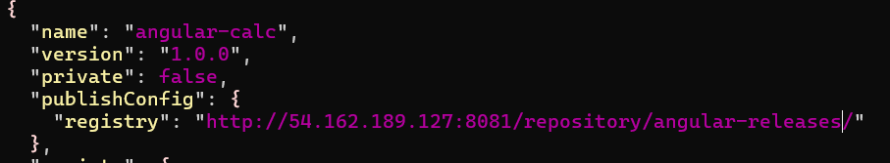
- Copy package.json file to build file in /dist i.e angularCalc
cp ~/AngularCalculator/package.json .
- Now login nexus repository on your Build-VM to give access to publish Artifact
npm login --registry=http://<nexus-ip>:8081/repository/angular-releases/ --auth-type=legacy
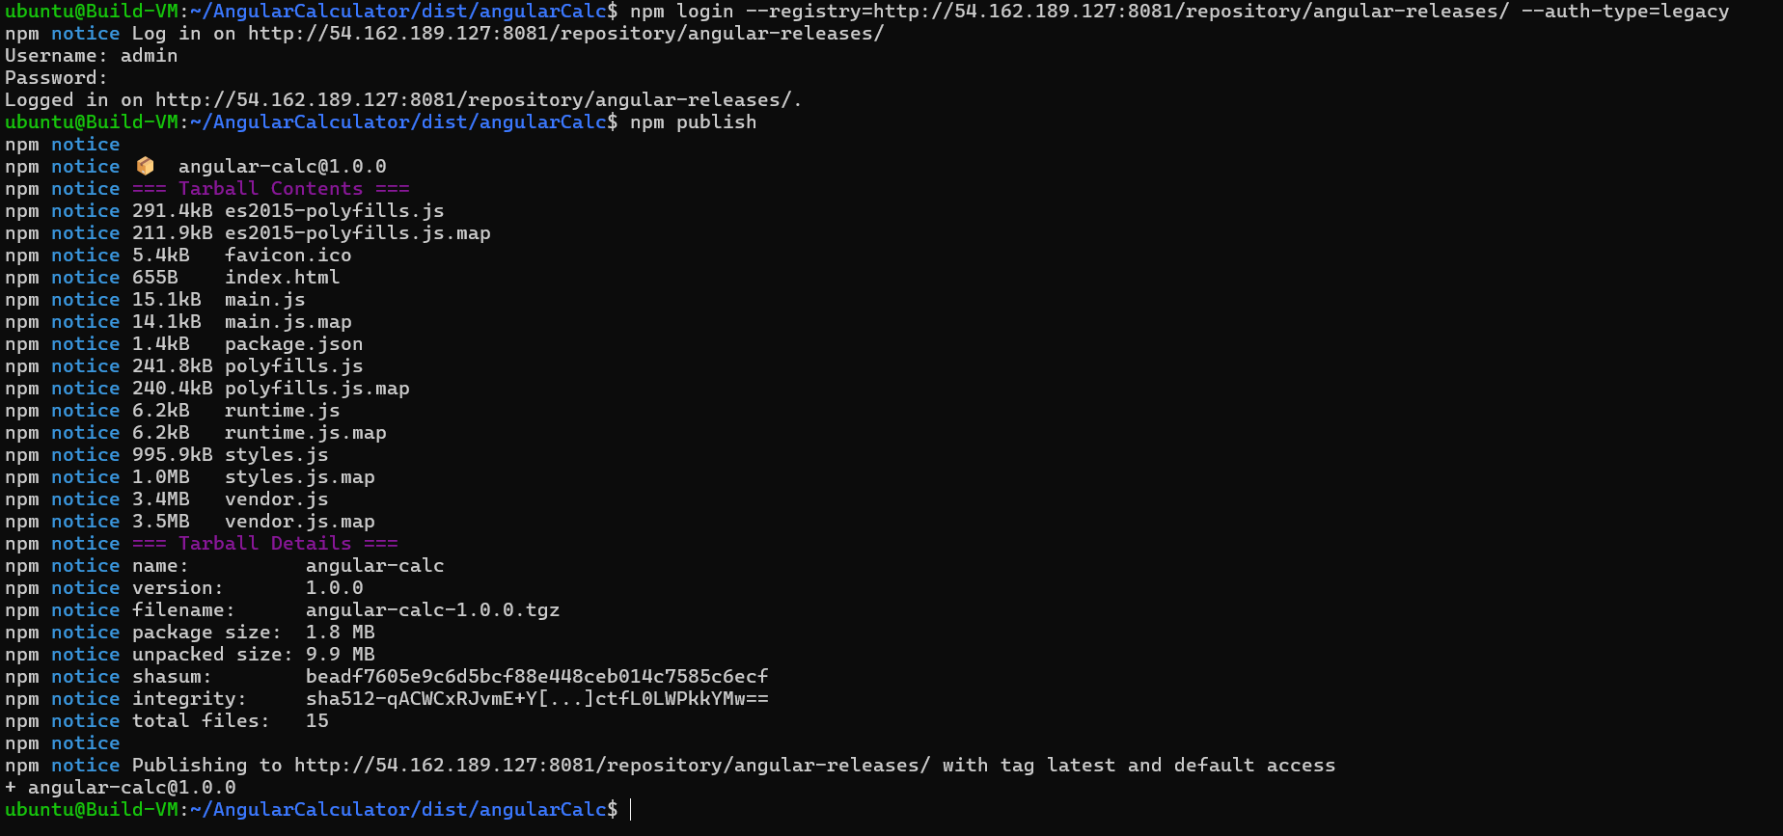
npm publish
- This pushes the artifact to nexus repository angular-releases
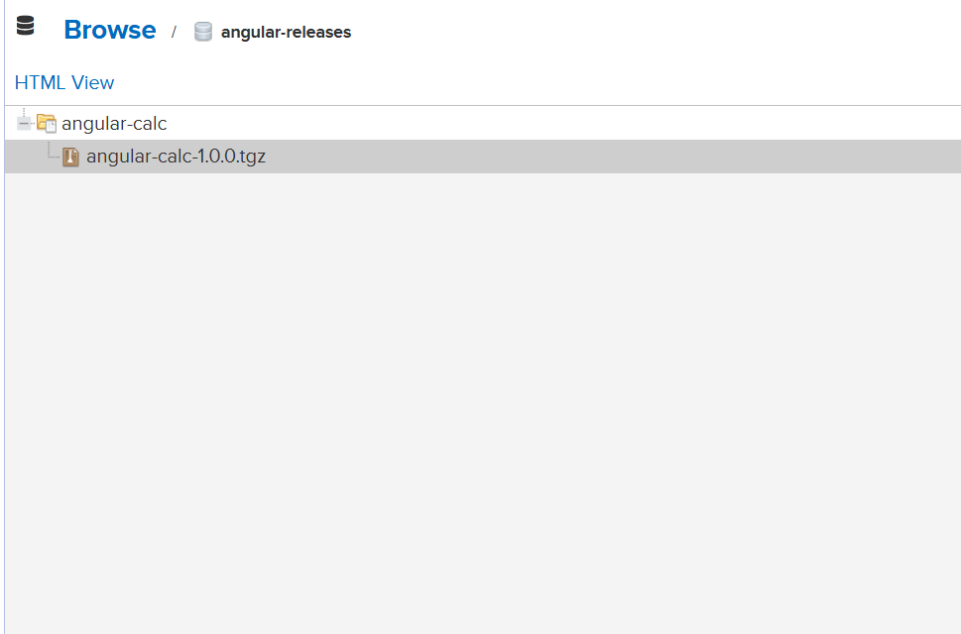
- Artifact in Nexus
Step-3: Deploy Server Setup (Deploy-VM)
- Launch Ec2 instance on AWS
- Name instance as Deploy-VM
- Select ubuntu AMI
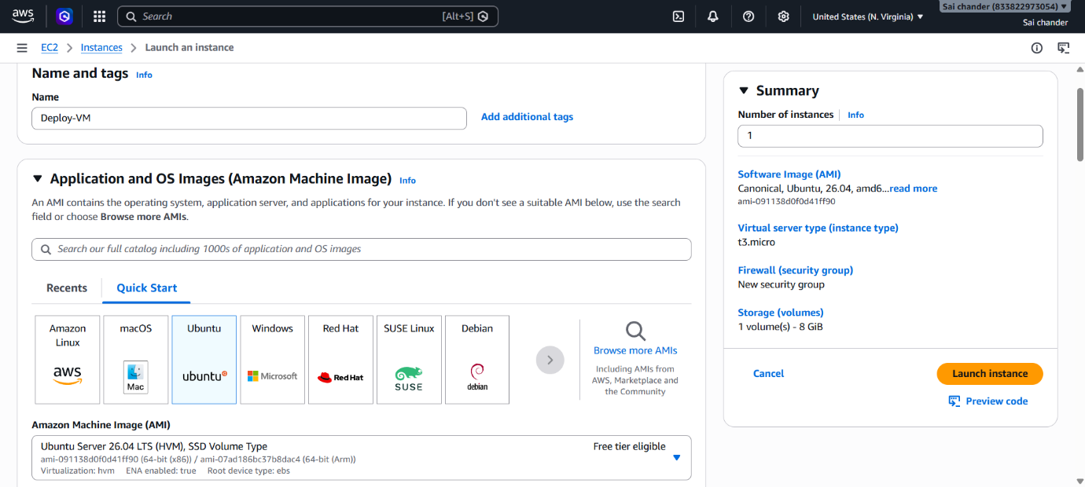

- Select Instance type t3.micro with 2vCPU and 1GB memory, keypair
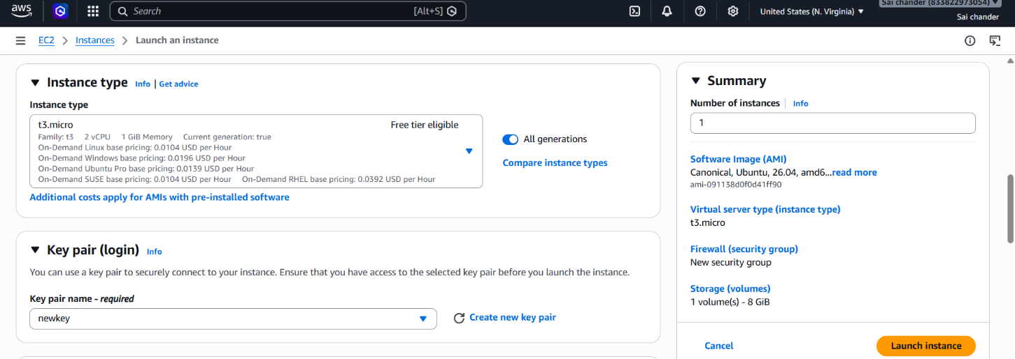
- Security Group rules - SSH port 22 and port 80(Nginx)
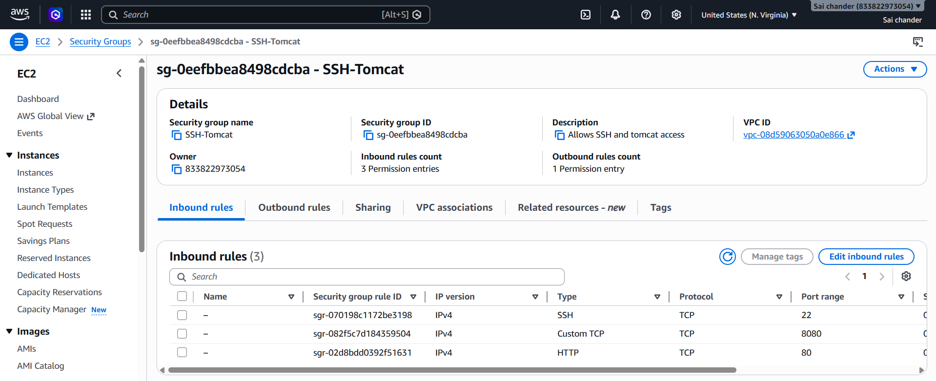
- Launch Instance
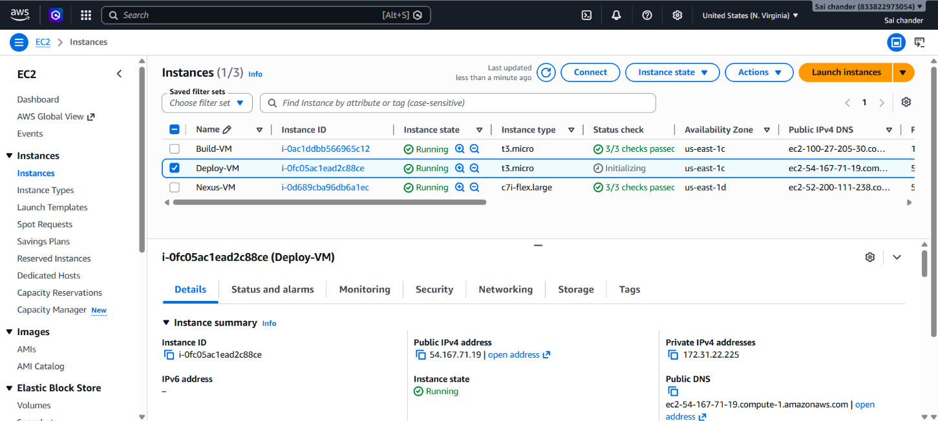
- Connect to terminal via SSH client
- Install nginx
sudo apt install nginx -y
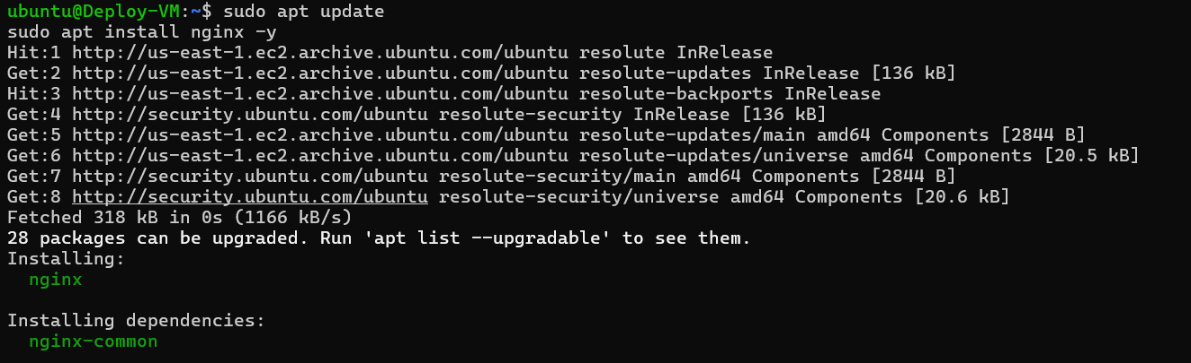
- Download artifact from nexus using link address of artifact
wget http://54.162.189.127:8081/repository/angular-releases/angular-calc/-/angular-calc-1.0.0.tgz
- extract files from the downloaded artifact
tar -xvzf angular-calc-1.0.0.tgz
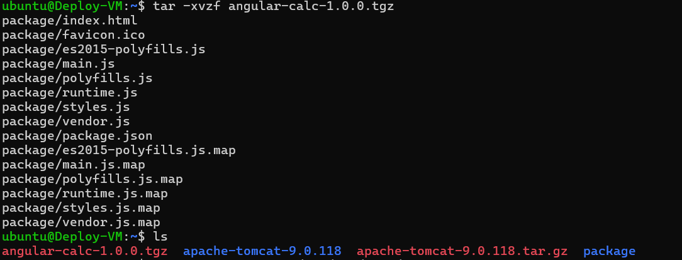
- copy build files to /var/www/html/
sudo cp -r package/* /var/www/html/
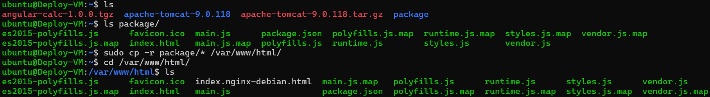
- Remove existing .html file i.e index.nginx-debian.html
sudo rm index.nginx-debian.html

- Restart nginx
sudo systemctl restart nginx
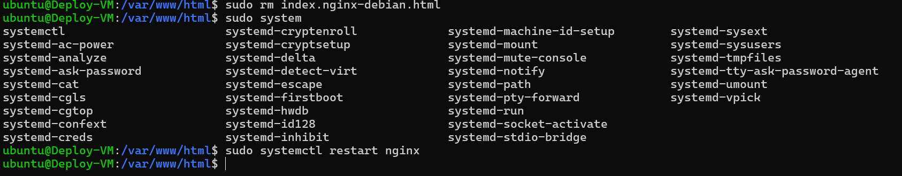
- Node.js application is running successfully on browser
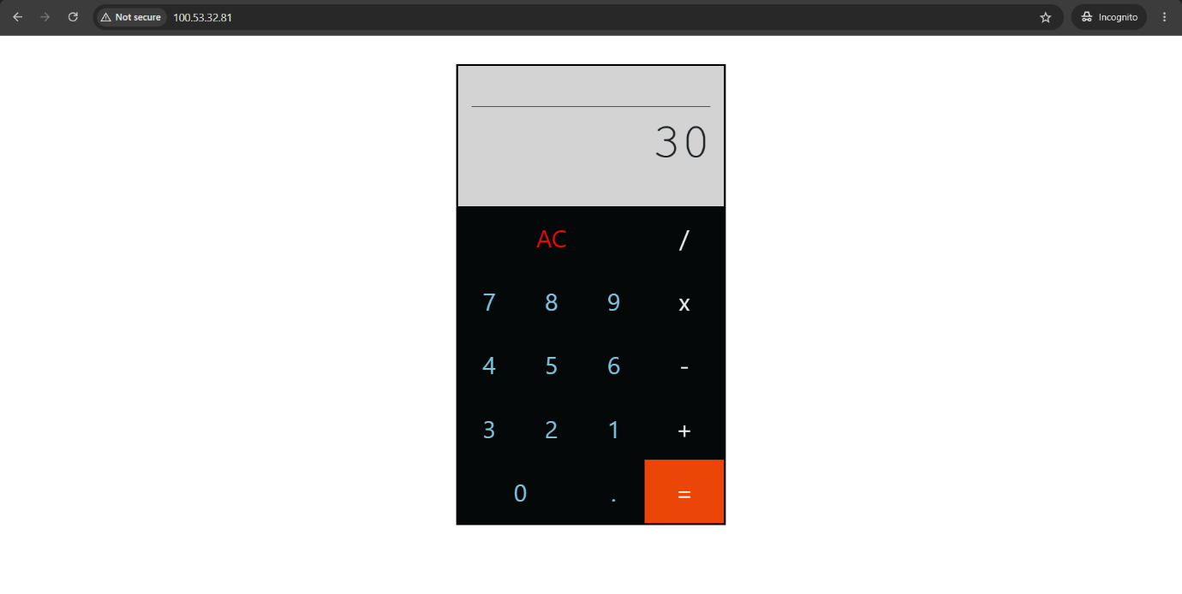

Issues encountered and resolution
- Error while building using ng build
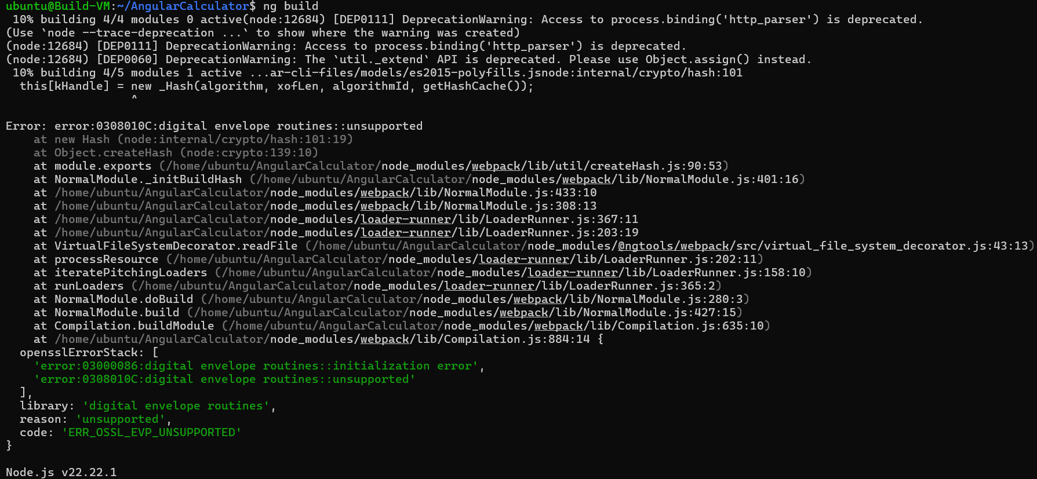
Resolution
- Used Legacy provider during build
export NODE_OPTIONS=--openssl-legacy-provider
- This is an environment variable command used to fix compatibility issues between node.js 17+ and older project dependencies

Conclusion
This task completes a basic DevOps pipeline for a Node.js application using a separate Build Server, Nexus Repository Server, and Deploy Server with Nginx as reverse proxy. The application is built, stored, deployed, and verified through the browser as required by the assignment

